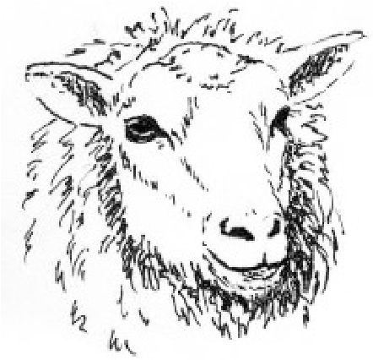 |  | Finnsheep Breeders Association |  |  |  |  |  |  |  |  | Purebred EWE
 |  | REGISTRATION APPLICATION
 |  | Phone: 785-456-8500 ● PO Box 27 - Sedalia, MO 65302 ● Fax:785-456-8599
 |  | Directions: Complete steps 1-18 and mail to the above address. Payment must accompany form. Detailed instructions are available online at www.finsheep.org
 |  | 1 Bred By: . |  |  |  |  |  |  | 2 Owned By: .
 |  | (Owner of Dam at Time of Mating) |  |  |  |  |  |  | (Owner of Dam at Time of Birth)
 |  | Address: |  |  |  |  |  |  | Address:
 |  | St/Rt/Box: . |  |  |  |  |  |  | St/Rt/Box: .
Sr. Member # . |  | City: ST: Zip: . |  |  |  |  |  |  | City: ST: Zip: .
Jr. Member # . |  | Phone: Email: . |  |  |  |  |  |  | Phone: Email: .
Non-Member # .
*Color: W=White; BL=Black; BR=Brown; G=Grey; F=Fawn **Marking: Bgr=Badgerface; RBgr=Reverse Badgerface; Bu=Blue; S=Solid ***Spotting: Pie=Piebald; HST=Head, Socks & Tail
ANIMAL TO BE REGISTERED |  |  |  |  |  |  | SIRE |  | DAM |  |  |  | TRANSFER
Leave Blank For Office Use Only | 3  Name of Animal Private Flock Tag | 4  Birthdate | 5  Litter Size | 6  Color* | 7  Marking** | 8  Spotting*** | 9  FBA Reg Number | 10  Name of Animal Private Flock Tag | 11  FBA Reg Number | 12  Name of Animal Private Flock Tag | 13  Months Lambing Age | 14  Date Sold, If Sold |  | 15  To Whom & Address (Enclose Transfer Fee)
SAMPLE | Huber 09-26 | 2-27-14 | 2 | BL | S | Pie | 82445 | Wilson 50 | 82446 | Wilson 51 | 22 | ---------- |  | --------------------
 |  |  | EWE
ATTENTION  ● Please sign as Dam or Sire Owner or Both  ● Please Check Work for Accuracy  ● After Completion, Please Keep a Copy of this Form in Your File |  | 18 .  Payment Must Accompany Registration  Refer to Fee Schedule for all Fees |  |  |  |  | 16 SIGNATURE OF OWNER OF DAM .  (time of lambing) Date .
17 SIGNATURE OF OWNER OF RAM .
(time of mating) Date .
 |  |  |  |  |  |  | Applications completed by partnership must also bear signature of a person authorized to sign for account.
Signature above represents:
"The information here is correct to the best of my knowledge and belief"

